Arduino based People counter

What’s a people counter?

It’s a mechanical device which is most times used to count readings with a button. Most times it’s in the shape of a stopwatch.

How does this counter work?

This sensor works with three sensors. Two on the outside and one in between.

* If someone goes past the inside sensor and afterwards past the middle sensor the amount of people shown on the Arduino gets reduced by one
* If someone goes past the outside sensor and afterwards past the middle sensor the amount of people shown on the Arduino gets raised by one
* If someone keeps standing in front of the middle sensor it will keep outputting a message to clear the way.

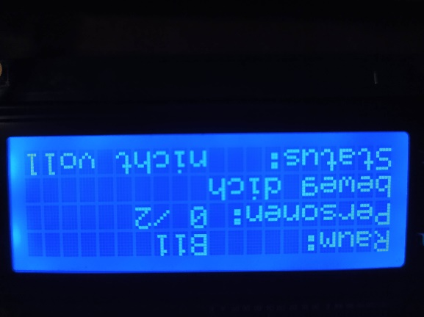The first line shows the room’s name.

In the second line it does tell how many people are inside the room out of the maximum allowed amount of people. 0 are inside, 2 are the maximum.

Line three outputs an error whenever the way gets blocked.

Last, but not least line four. It shows whether or not the room is full.

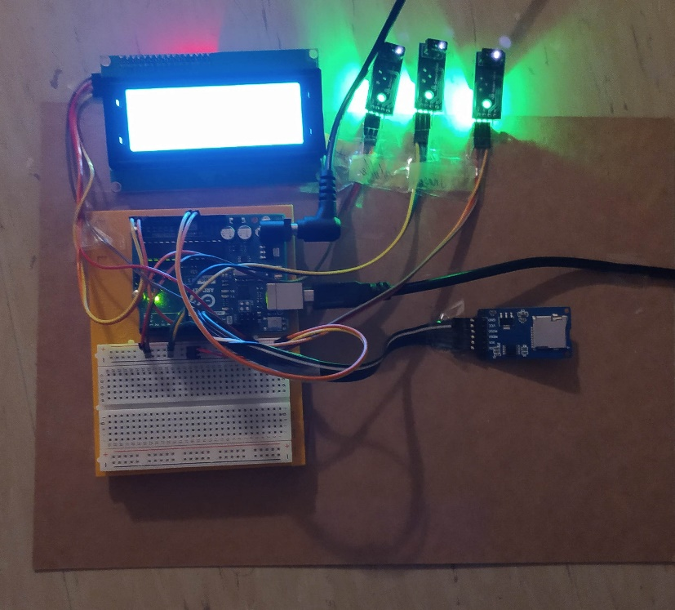Here’s an example of how the finished counter may look like.

First there’s the output device, the lcd, is marked red.

Then there’s the input device, the sensors, which are marked blue.

In the yellow marked square is the SD module which saves all recorded data

Last, but not least, the Arduino itself, which is marked green. It is used for the entire processing of the inputs and outputs.